13EE4218-POWER SYSTEM OPERATION & CONTROL (EEE)
UNIT-I

ECONOMIC OPERATION OF POWER SYSTEMS: Statement of economic dispatch problem – Economic Dispatch Problem, input output curves of thermal power plants-Thermal System Dispatching with network Losses, Lambda –Iteration method (No derivation of loss coefficients).
UNIT – II
HYDROTHERMAL SCHEDULING: Introduction, Hydroelectric power plant models, scheduling problems (Problems for one Iteration) - Implementation of Short term Hydrothermal scheduling problem.
UNIT COMMITMENT: Need for Unit Commitment, Unit Commitment solution methods-Priority lists method, Forward Dynamic Programming method, spinning reserve.
UNIT-III
REACTIVE POWER AND VOLTAGE CONTROL: Basic generator control loops, Cross- coupling between control loops, Exciter types, Exciter modelling, Generator modelling, and Static performance of AVR loop.
Generation and absorption of reactive power, relation between voltage, power and reactive power at a node, single machine infinite bus systems, methods of reactive power control.
UNIT-IV
AUTOMATIC LOAD FREQUENCY CONTROL: Automatic Load frequency control of single area systems, Speed-governing system, Turbine generator response, Static performance of speed governor, Closing of ALFC loop, Concept of control area, Static response of primary ALFC loop, Integral control, ALFC of multi-control area systems (POOL operation), The Two- Area system, Modeling the Tie-Line, Block Diagram representation of Two-Area system, Static response of Two-Area system and Tie-Line Bias control.
UNIT- V
COMPUTER CONTROL OF POWER SYSTEMS: Main Tasks in Power System Operation, SCADA: Division of Tasks between Various Control Centers, Features of SCADA Systems, SCADA Configuration, Energy Management Systems System operating states , System Security, State Estimation

TEXT BOOKS
1. “Power generation, operation and control” by Allen J Wood & Woollenberg. John Wiley and Sons.
2. “Electrical Energy Systems Theory” by O.J Elgerd.
3. “A Text book on Power System engineering” by M.L. Soni, P.V. Gupta, U.S. Bhatnagar- Dhanpatrai &co
4. “Switch Gear and Protection”, by Sunil S. Rao, Khanna Publishers, New Delhi.

REFERENCES:
1. “Computer Aided Power System Analysis” by G.L.Kusic.
2. “Power System Analysis, Operation and Control” by Abhijit Chakrabarti and Sunita Halder, PHI.
3. “Electric Power Systems” by B.M.Weedy and B.J. Cory.
4. “Modern Power System Analysis” by I J Nagarath and D P Kothari, TMH.

UNIT-I
ECONOMIC OPERATION OF POWER SYSTEMS
Planning, operation and control of interconnected power systems presents a variety of challenging problems.
An important problem in this area is the economic operation of the system, which means, that every step in planning, scheduling and operation of the system, unit-wise, plant wise and inter connection-wise must be optimal, leading to absolute economy.
In this, the transmission losses too play an important role. In this unit on economic operation of power system, both thermal and hydro system will be dealt with using suitable analytical models that result in meaningful savings.
DEFINITION OF ECONOMIC DISPATCH
Economic dispatch problem means that determination of generation of different units such that total fuel cost is minimum and at the same time total demand and losses at any instant must be met by total generation.
ECONOMIC LOAD DISPATCH:
Economic load dispatch is defined as the allocation of real power demand among available generating units in the plant while satisfying the equality and inequality constraints.
The main objective of the economic load dispatch is to reduce the total fuel cost of the plant.
(i) Equality constraint: P_{G}= P_{D} + P_{L}
(ii) Inequality constraint: P_{Gmin} < P_{Gi} < P_{Gmax}
ECONOMIC LOAD DISPATCH PROBLEM
Economic Dispatch
- The objective of economic load dispatch of electric power generation is to schedule the committed generating unit outputs so as to meet the load demand at minimum operating cost while satisfying all units and operational constraints of the power system.
- The economic dispatch problem is a constrained optimization problem and it can be mathematically expressed as follows:
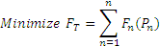(or)
$C_{T}=$$\sum_{i=1}^{k}{}C_{i}(P_{\text{Gi}})$
where, F_{T} : total generation cost (Rs/hr)
n : number of generators
P_{n} : real power generation of n^{th} generator (MW)
f_{n} (P_{n}) : generation cost for P_{n}

Subject to a number of power systems network equality and inequality constraints.
1.1 CHARACTERISTICS OF STEAM PLANTS :
In analyzing the economics of operation of thermal systems, modelling of input output characteristics assumes significance. For this purpose a single unit comprising of boiler, turbine, and generator may be considered.
The unit has to supply power to the local needs for the auxiliaries in the station. This later component may be around 2-5%.
The station auxiliaries includes boiler feed pumps, condenser circulating water pumps, fans etc.
The total input to the unit could be either K-cal/hr in terms of heat supplied or Rs/hr in terms of the cost of the fuel such as coal, gas or fossil fuel of any other form.
The net output of the unit that is supplied into the system at the generator bus will be in KW or MW.
Scheduling is the process of allocation of generation among various operating generator units.
Economic scheduling is the cost effective mode of generation allocation among the various units. This can also be termed as optimal operation.
The analytical solution proposed in general for optimal operation depends on incremental cost concept.
.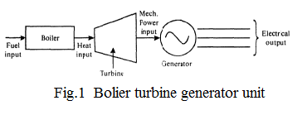
1.2 INPUT OUTPUT CURVES:
It has been already stated the input output characteristics for any thermal unit can be obtained from the operating data. The input can be in kilo calories per hour and the output may be in kilowatts or preferably in mega watts. Typical characteristic is shown in below Fig, for the unit shown in above Fig.
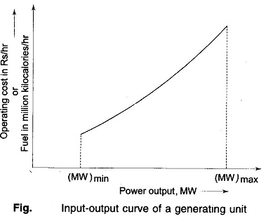
1.3 THE INCREMENTAL HEAT RATE ( FUEL RATE) CHARACTERISTIC:
From the input output characteristic the incremental heat rate characteristic can be obtained which is the ratio of the differentials.
Incremental fuel rate or heat rate = 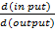
By calculating the slope of the characteristic in input-output curve at every point, the incremental fuel rate characteristic can be plotted as shown in below.
This characteristic infact tells about the thermal efficiency of the unit under consideration that can be used for comparison with other units in performance.
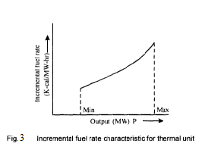
1.4 THE INCREMENTAL FUEL COST CHARACTERISTIC:
The incremental fuel rate in K-caI/Kw-hr (K-caI/Mw-hr) can be multiplied by cost-of the fuel in terms of Rs per K-cal (Rs/K-cal). In any case the ordinates are in Rs/Kw-hr. or Rs/MW-hr. The calorific value of the fuel is required in these calculations. This characteristic is shown in below Fig.
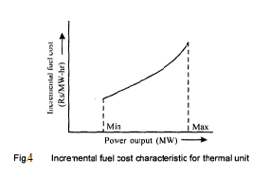
1.5 HEAT RATE CHARACTERISTIC :
Some times the unit net heat rate characteristic is also considered important. To obtain this characteristic the net heat rate in k-cal /Mw-hr is plotted against the power output (Mw) (below Fig).
The thermal efficiency of the unit is influenced by factors like steam condition, reheat stages, condenser pressure and the steam cycle used. The efficiency of the units in practice is around 30%.
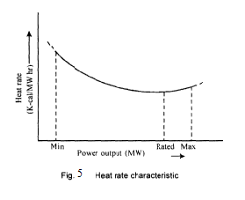
1.6 INCREMENTAL PRODUCTION COST CHARACTERISTICS:

- The production cost of the power generated actually depends on several items such as fuel cost, labour charges, cost of items such as oil, water and other supplies needed and also the cost of maintenance.
- It is well known that in thermal generation the fuel cost is by far the largest cost head and is directly related to the power generated.
- Even the other charges, that is the additional running expenses too are, more or less, related to the amount of generation. Thus, it is a simple practical proposition to assume that, all the additional costs as a fixed percentage of the incremental fuel cost.
- The sum of incremental fuel cost and other incremental running expenses is called incremental production cost.
- The ordinates of incremental fuel cost characteristics will also represent incremental production cost to some other scale.
- An explicit mathematical relationship involving all the factors involved in power generation to the total power generated is in fact a very difficult task.
- In general, the input-output data is fitted into a quadratic characteristic even though it is also possible to fit into any polynomial curve for ease of mathematical manipulation.

OPTIMAL OPERATIONS OF GENERATORS ON A BUS BAR: (ECONOMIC DISPATCH WITHOUT LOSSES)

Generator cost
The major component of generator operating cost is the fuel input/hour, while maintenance contributes only to a small extent. The fuel cost is meaningful in case of thermal and nuclear stations, but for hydro stations where the energy storage is ‘apparently free’, the operating cost as such is not meaningful.
The input-output curve of a unit can be expressed in a million kilocalories per hour or directly in terms of rupees per hour versus output in megawatts. The cost curve can be determined experimentally.
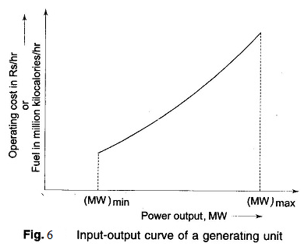
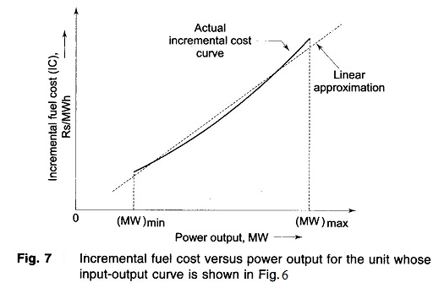
A typical curve is shown in above Fig. where (MW)_{min} is the minimum loading limit below which it is uneconomical (or may be technically infeasible) to operate the unit and (MW)_{max} is the maximum output limit.
By fitting a suitable degree polynomial, an analytical expression for operating cost can be written as
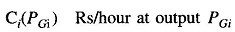
where the suffix i stands for the unit number. It generally suffices to fit a second degree polynomial, i.e.
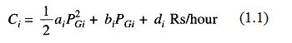
The slope of the cost curve, i.e. dC_{i}/dP_{Gi} is called the incremental fuel cost (IC), and is expressed in units of rupees per megawatt hour (Rs/MWh). A typical plot of incremental fuel cost versus power output is shown in Fig. 7. If the cost curve is approximated as a quadratic as in Eq. (1.1), we have
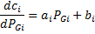
i.e. a linear relationship.
For better accuracy incremental fuel cost may be expressed by a number of short line segments (piecewise linearization). Alternatively, we can fit a polynomial of suitable degree to represent IC curve in the inverse form.
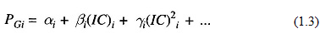

Optimal Operation:
Let us assume that it is known a priori which generators are to run to meet a particular load demand on the station. Obviously
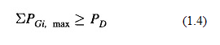
where P_{Gi,} max is the rated real power capacity of the i_{th} generator and P_{D} is the total power demand on the station. Further, the load on each generator is to be constrained within lower and upper limits, i.e.
Considerations of spinning reserve, to be explained later in this section, require that
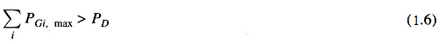
by a proper margin, i.e. Eq. (1.6) must be a strict inequality.
The question that has now to be answered is: ‘What is the optimal manner in which the load demand P_{D} must be shared by the generators on the bus?’ This is answered by minimizing the operating cost

$C_{T}=$$\sum_{i=1}^{k}{}C_{i}(P_{\text{Gi}})(1\text{.}7)$
under the equality constraint of meeting the load demand, i.e.
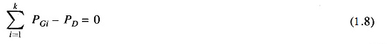
where k = the number of generators on the bus.
Further, the loading of each generator is constrained by the inequality constraint of Eq. (1.5).
Since C_{i}(P_{Gi}) is non-linear and C_{i} is independent of P_{Gj} (j≠i), this is a separable non-linear programming problem.
If it is assumed at present, that the inequality constraint of Eq. (1.4) is not effective, the problem can be solved by the method of Lagrange multipliers. Define the Lagrangian as
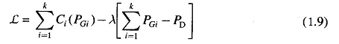
where λ is the Lagrange multiplier.
Minimization is achieved by the condition
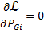
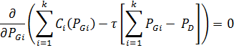
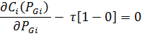
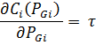(or)
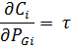

(or)
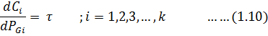
where dC_{i}/dP_{Gi} is the incremental cost of the ith generator (units: Rs/MWh), a function of generator loading P_{Gi}. Equation (1.10) can be written as
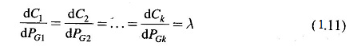
i.e. the optimal loading of generators corresponds to the equal incremental cost point of all the generators. Equation (1.11), called the coordination equations numbering k are solved simultaneously with the load demand equation (1.8) to yield a solution for the Lagrange multiplier λ and the optimal loading of k generators.
ALGORITHM FOR ECONOMIC LOAD DISPATCH PROBLEM USING LAMBDA ITERATION METHOD NEGLECTING LOSSES
A set of non linear equations that economical load dispatch without losses are given as
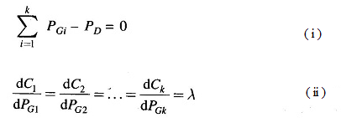
The solution must be obtained iteratively keeping in view that inequality constraint is to be considered.
λ- iteration method:
The iterative method steps are
Step-1: Assume a suitable value of λ⁽⁰⁾. This value should be more than intercepts of incremental cost characteristics of various generators.
Step-2: Knowing the value of λ⁽⁰⁾ from the Equation(ii); Compute individual generations P₁,P₂,.....P_{k} corresponding to the incremental cost equations. In case of violation for a generation value of the generator, it is fixed at the limit violated and remaining load is distributed among the remaining generators.

Step-3: Knowing the value P_{load}, check whether the equation (i) is satisfied or not.
Step-4: If equality is not maintained or met choose a second guess λ⁽¹⁾ and repeat the above steps. The value of λ⁽¹⁾ will be decided from equation (i).
Example: If the sum of the generation is less than P_{D}
choose λ⁽¹⁾ > λ⁽⁰⁾ otherwise λ⁽¹⁾ < λ⁽⁰⁾
Step-5: If equation (i) is satisfied generations as calculated in step-2 gives the optimum operating schedule.

